Cross-quantilogram: EURUSD and AUDUSD
Method 20 / daily log returns / expanding quantiles / Alpari D1 full available history

Study setup
Logical pair: EURUSD , AUDUSD
Broker symbols: EURUSD_i , AUDUSD_i
Snapshot: 2026-11-03_majors_alpari_D1
Timeframe: D1
Matched return window: 1999-01-05 to 2026-11-02 (UTC bar dates)
Matched return count n: 7201
Dropped unfinished last bar dated 2026-11-03 UTC after a tick-volume check against the prior complete day.
Quantiles: expanding window, min history 252 days
tau in [0.05, 0.2]; k=0..10; headline tau=0.05, k=1
Complete matched rows (Excel): EURUSD-AUDUSD_CQ_D1.xlsx
Complete matched rows (HTML table): EURUSD-AUDUSD_CQ_D1_data.html

Method carried forward
The cross-quantilogram rho_tau(k) measures linkage among centered quantile-hit indicators of matched daily log returns of close, ln(close_t / close_t-1). Quotes are not inverted. At each date t, the tau-quantile uses only returns through t (expanding window) after a minimum history of 252 days. Hits are h_t = 1(r_t < q_t) - tau. rho_tau(k) is the normalized cross-product of h_x,t with h_y,t+k. Levels tau in {0.05, 0.20} and lags k=0..10 are pre-specified; headline is tau=0.05, k=1 both directions. Same-sample Pearson r is a side check. This is not causation and not a trading signal.

Results (headline)
rho_EURUSD->AUDUSD(tau=0.05,k=1): 0.066796
rho_AUDUSD->EURUSD(tau=0.05,k=1): 0.055425
rho_EURUSD->AUDUSD(tau=0.20,k=1): 0.051730
rho_AUDUSD->EURUSD(tau=0.20,k=1): 0.020591
Pearson r: 0.556324

CQ table (tau=0.05)
k | rho_EURUSD_to_AUDUSD | n_EURUSD_to_AUDUSD | rho_AUDUSD_to_EURUSD | n_AUDUSD_to_EURUSD
0 | 0.32076023 | 6950 | 0.32076023 | 6950
1 | 0.06679647 | 6949 | 0.05542525 | 6949
2 | 0.05162586 | 6948 | 0.04025452 | 6948
3 | 0.04024543 | 6947 | 0.05540736 | 6947
4 | 0.05539841 | 6946 | 0.05918893 | 6946
5 | 0.02506504 | 6945 | 0.05918002 | 6945
6 | 0.05158993 | 6944 | 0.05538052 | 6944
7 | 0.06674346 | 6943 | 0.04020907 | 6943
8 | 0.06294396 | 6942 | 0.04778131 | 6942
9 | 0.05156299 | 6941 | 0.03260949 | 6941
10 | 0.05534474 | 6940 | 0.0401818 | 6940

Conclusion
Headline tau=0.05, k=1 for EURUSD and AUDUSD: rho_EURUSD->AUDUSD = 0.0668; rho_AUDUSD->EURUSD = 0.0554. At tau=0.20, k=1: 0.0517 and 0.0206. Same-day tau=0.05 rho(k=0) = 0.3208. Pearson r = 0.5563. This is quantile-hit linkage, not a trading signal.

Charts
Daily closes

Daily log returns

Cross-quantilogram tau=0.05
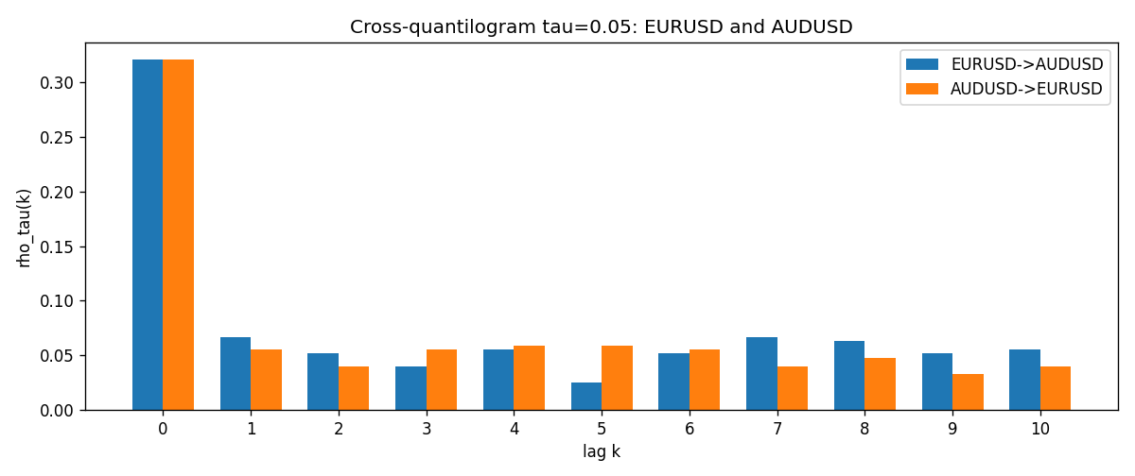

Data report
Matched rows and the CQ sheet are in the sibling Excel workbook named EURUSD-AUDUSD_CQ_D1.xlsx. Embedding all rows as a Word table is impractical; this file holds column summaries and the first and last 15 matched rows.
Columns: time, EURUSD_open, AUDUSD_open, EURUSD_high, AUDUSD_high, EURUSD_low, AUDUSD_low, EURUSD_close, AUDUSD_close, EURUSD_tick_volume, AUDUSD_tick_volume, EURUSD_spread, AUDUSD_spread, EURUSD_real_volume, AUDUSD_real_volume, EURUSD_log_return, AUDUSD_log_return, EURUSD_h_t005, AUDUSD_h_t005
Column summaries (matched calculation rows)
column | count | mean | std | min | 25% | 50% | 75% | max
EURUSD_open | 7201 | 1.1813268 | 0.15086382 | 0.8272 | 1.08608 | 1.16615 | 1.29393 | 1.5995
AUDUSD_open | 7201 | 0.75197127 | 0.13525779 | 0.4785 | 0.66105 | 0.73142 | 0.80912 | 1.10284
EURUSD_high | 7201 | 1.1864593 | 0.1514619 | 0.8326 | 1.0902 | 1.17128 | 1.29926 | 1.6038
AUDUSD_high | 7201 | 0.75602178 | 0.13581838 | 0.4878 | 0.6647 | 0.7349 | 0.81518 | 1.10795
EURUSD_low | 7201 | 1.1763142 | 0.15018707 | 0.8227 | 1.08202 | 1.16257 | 1.28834 | 1.5865
AUDUSD_low | 7201 | 0.74791431 | 0.13457219 | 0.4775 | 0.6577 | 0.72758 | 0.8042 | 1.0975
EURUSD_close | 7201 | 1.1813656 | 0.15083992 | 0.8267 | 1.08601 | 1.16617 | 1.29395 | 1.5997
AUDUSD_close | 7201 | 0.75202148 | 0.13524071 | 0.4786 | 0.6612 | 0.73175 | 0.80916 | 1.10169
EURUSD_tick_volume | 7201 | 103004.8 | 173409.64 | 469 | 9389 | 52708 | 99441 | 1471626
AUDUSD_tick_volume | 7201 | 77347.024 | 138135.9 | 109 | 5434 | 43320 | 71320 | 1234623
EURUSD_spread | 7201 | 19.396195 | 16.574381 | 0 | 8 | 12 | 30 | 50
AUDUSD_spread | 7201 | 30.819886 | 16.887485 | 0 | 13 | 30 | 50 | 50
EURUSD_real_volume | 7201 | 4.0238636e+10 | 1.6675367e+11 | 0 | 0 | 0 | 0 | 3.6149665e+12
AUDUSD_real_volume | 7201 | 5.2420906e+09 | 1.2538049e+11 | 0 | 0 | 0 | 0 | 3.811512e+12
EURUSD_log_return | 7201 | -7.54e-06 | 0.00580172 | -0.03123819 | -0.00324684 | 0 | 0.00325501 | 0.03433183
AUDUSD_log_return | 7201 | 2.459e-05 | 0.00754509 | -0.08602525 | -0.00385511 | 0.00028229 | 0.00415126 | 0.0806166
EURUSD_h_t005 | 6950 | -0.01676259 | 0.17926882 | -0.05 | -0.05 | -0.05 | -0.05 | 0.95
AUDUSD_h_t005 | 6950 | -0.00338129 | 0.21083595 | -0.05 | -0.05 | -0.05 | -0.05 | 0.95
First 15 matched rows (selected columns)
time | EURUSD_log_return | AUDUSD_log_return | EURUSD_h_t005 | AUDUSD_h_t005
1999-01-05 | -0.0048360507 | -0.00080418179 | nan | nan
1999-01-06 | -0.011547966 | 0.011836351 | nan | nan
1999-01-07 | 0.0076280636 | 0.0088650256 | nan | nan
1999-01-08 | -0.010902799 | 0.00031515916 | nan | nan
1999-01-11 | -0.007103287 | 0.0072213815 | nan | nan
1999-01-12 | 0.0045103728 | -0.0048608485 | nan | nan
1999-01-13 | 0.010845346 | -0.0078902098 | nan | nan
1999-01-14 | 0 | -0.002696916 | nan | nan
1999-01-15 | -0.010153245 | 0.007123101 | nan | nan
1999-01-18 | 0.0036256946 | 0.00094592471 | nan | nan
1999-01-19 | -0.00017235436 | 0.0072225153 | nan | nan
1999-01-20 | -0.0031939256 | 0.0012507819 | nan | nan
1999-01-21 | 0.0030215416 | 0.00078094498 | nan | nan
1999-01-22 | -0.0012075213 | -0.012252745 | nan | nan
1999-01-25 | -0.0030251979 | -0.0039591468 | nan | nan
Last 15 matched rows (selected columns)
time | EURUSD_log_return | AUDUSD_log_return | EURUSD_h_t005 | AUDUSD_h_t005
2026-10-13 | 0.0037402957 | 0.0035007712 | -0.05 | -0.05
2026-10-14 | -0.0037582255 | -0.0015193215 | -0.05 | -0.05
2026-10-15 | 0.0056053107 | -0.0075447063 | -0.05 | -0.05
2026-10-16 | 0.0017724895 | 0.0033906408 | -0.05 | -0.05
2026-10-19 | -0.0025394633 | 0.0050859986 | -0.05 | -0.05
2026-10-20 | 0.0023881672 | 0.0034620426 | -0.05 | -0.05
2026-10-21 | -0.00032046717 | 0.0036066384 | -0.05 | -0.05
2026-10-22 | -0.0015949606 | -0.0012672558 | -0.05 | -0.05
2026-10-23 | -0.001338521 | 0.0023765656 | -0.05 | -0.05
2026-10-26 | -0.0022706559 | -0.0032032829 | -0.05 | -0.05
2026-10-27 | -0.004152342 | 0.0016669876 | -0.05 | -0.05
2026-10-28 | 0.0022262927 | 0.0040915541 | -0.05 | -0.05
2026-10-29 | 0.0022571351 | -0.0040915541 | -0.05 | -0.05
2026-10-30 | -0.0011458446 | 0.0010102376 | -0.05 | -0.05
2026-11-02 | 0.002120569 | -0.0049184984 | -0.05 | -0.05

